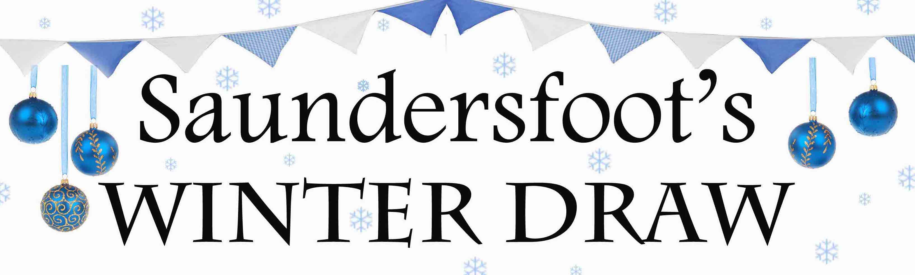

List of Prize Winners

Two night off-peak break with dinner for two at St Brides Spa Hotel – Kay Howells (online entry)

Clogau Lovespoons Necklace from The Silver Lily – Mrs Sillick

Three course meal for two at The BoatHouse – Angela Bobby Mills

A 2018 Car Park Season Ticket for Coppet Hall carpark donated by Hean Estate – James Shields

A Will consultation and the preparation of two Wills for the winner and their partner from Pembrokeshire Wealth Management – Rhys Donovan

Ceramic Pottery Painting for two plus £10 towards food at Periwinkle Café – ‘Gareth’

An overnight stay for two plus an amazing breakfast at Cliff House Guest House – ‘Spencer’

£50 voucher to spend at Heywood's Butchers – Edward Phillips

An overnight stay for two including breakfast at Woodlands Hotel – ‘Vivien’

Two course meal for two at The Chemist Inn – David Slade (online entry)

£125 voucher towards a two night stay at Stoney Bridge B&B – Neville B-T

Two course Sunday lunch for two people at The Mulberry Restaurant – Leah Uka

One month’s family swim membership (for 4) at Swallow Tree – ‘The Oldhams’ (online entry)

£50 voucher for any Saundersfoot restaurant from Edith Cottage Saundersfoot – A Hesford

Giant Sweetie Hamper from Rock & Fudge Shop – Phil S C Farm

£500 voucher towards an off-peak short break at Rhodewood Lodge – Stone Crab (online entry)

£50 M&S voucher from Nythfa Guest House – Gail Thomas (online entry)

£50 John Lewis voucher from 1Formula Fitness – Jez & Nigel Beynon

A voucher for any large framed photo (RRP £110) from Dilys Photography Gallery - Lynda

£50 voucher from The Lounge Coffee Shop – Richie Davies (online entry)

A facial with Dermalux light treatment from Eternal Aesthetics and Beauty – Hayley Subbiani (online entry)

A Sport fishing trip from Saundersfoot Pleasure Boats – Helen East

A bottle of Johnnie Walker Blue Label Whiskey from Phil & Ann Baker of Saundersfoot – Lucy Salder

£50 to spend in Beachside Barbeque – Rob Morgan

£25 to spend in Marina Fish Chips & More – Karin Preece

New Year's Day Swim shirt signed by Cardiff players from The NYDS Swim Committee – Rose Evans

Delicious pizza dinner for a family of four inc soft drinks from Little & Large Lite Bites – Linda Evans

£25 to spend at any Saundersfoot cafe or restaurant from Pen Mar Guest House – Julie Davies

A Stieff 'wild pussy cat' from Chobbles Traditional Sweet Shop – Steve Price

A Christmas Hamper from Spar – Helen Hedley (online entry)

A mackerel fishing trip donated by Saundersfoot Pleasure Boats – David Appleby

A mackerel fishing trip donated by Saundersfoot Pleasure Boats - Andrea Darlington (online entry)

